TELENCO UK WEBSITE SITEMAP & CONTENT STRUCTURE
HOME PAGE CONTENT
NAVIGATION LINKS & CONTENT
FOOTER SECTION
PRIVACY POLICY
T&C’s
ABOUT
FAQS
NEWS/BLOG
SHOWCASE / SERVICES
CONTACT
RETURNS POLICY
DELIVERY INFO
SUCCESS / CONFIRMATION
PUBLIC SHOP
PRODUCT CATALOGUE
CHECKOUT
PAYMENT
LOGIN
PRIVATE SHOP
PRODUCT CATALOGUE
CHECKOUT
PRODUCT BUNDLES
LOGIN
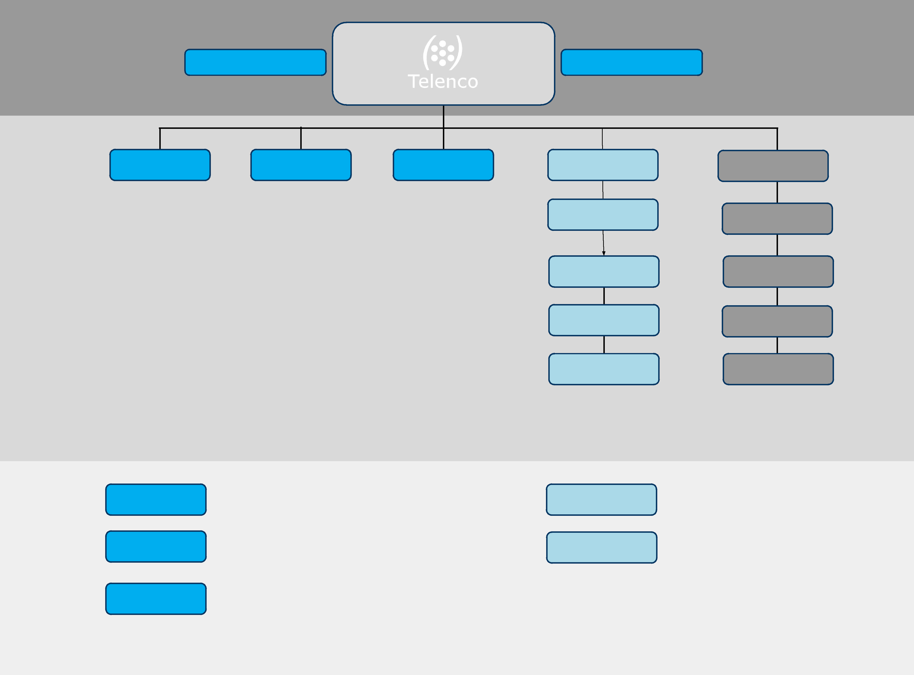

HOME PAGE
GENERIC CONTENT
PUBLIC SHOP
PRIVATE SHOP

